

**Planning Proposal**

**To amend State Environmental Planning Policy (Sydney Growth Centres) 2006 by rezoning land and permitting additional uses at 45 Hollinsworth Road, Marsden Park**

Part 1 – Objectives or intended outcomes 1

1.1 Introduction 1

1.2 Applicable land 1

1.3 Current planning controls 3

Part 2 – Explanation of provisions 5

2.1 Amendments to State Environmental Planning Policy 5

2.2 Mapping amendments 5

Part 3 – Justification 6

3.1 Section A – Need for the Planning Proposal 6

3.2 Section B – Relationship to strategic planning framework 6

3.3 Section C – Environmental, Social and Economic Impacts 7

3.4 Section D – State and Commonwealth interests 8

Part 4 – Mapping 9

Part 5 – Community consultation 9

Part 6 – Timeline 9

**Attachments**

Attachment 1: Consistency with Greater Sydney Region Plan, Central City Plan, Blacktown Community Strategic Plan and Blacktown Local Strategic Planning Statement

Attachment 2: Consistency with Applicable SEPPs and REPs

Attachment 3: Consistency with Relevant Section 9.1 Directions by the Minister

# Part 1 – Objectives or intended outcomes

## Introduction

This Planning Proposal seeks to amend Appendix 5, Schedule 1 of *State Environmental Planning Policy (Sydney Region Growth Centres) 2006* (the Growth Centres SEPP) to include ‘hotel or motel accommodation’ as an additional permitted land use at 45 Hollinsworth Road, Marsden Park (Lot 1 DP 1176437) and to rezone a part of the site that is zoned SP2 Infrastructure (Local Road) to B5 Business Development.

Miletic-Mieler Development Consultants on behalf of the Ahmadiyya Muslim Association Australia (AMAA) have requested this Planning Proposal.

## Applicable land

The Planning Proposal applies to land shown in Figure 1.

The site is located within the Marsden Park Industrial Precinct in the North West Growth Area. It is bounded by Richmond Road to the east, Langford Drive to the north and vacant land to the west and south.

There is a place of public worship on the site.

The site is accessed via an access handle from Hollinsworth Road zoned SP2 Infrastructure (Local Road) and is currently fenced and gated with no access to and from the adjoining sites and streets. There is no vehicular access from Richmond Road or Langford Drive to the site.

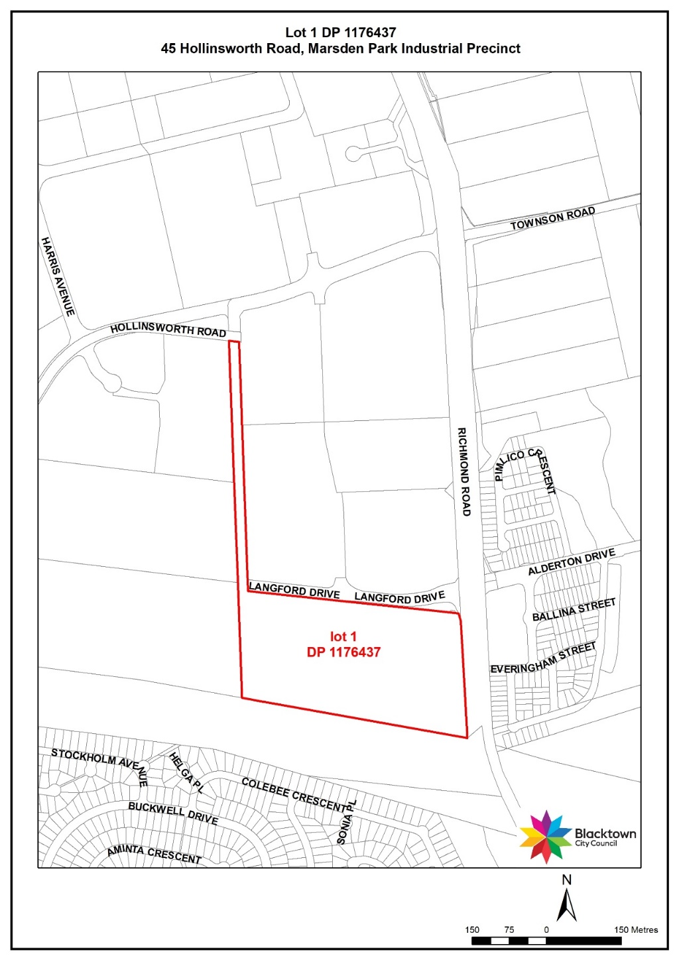

Figure 1 Applicable land

## Current planning controls

Appendix 5 (Marsden Park Industrial Precinct Plan), Schedule 1 of the Growth Centres SEPP applies to the subject land.

The land zoning is shown in Figure 2.

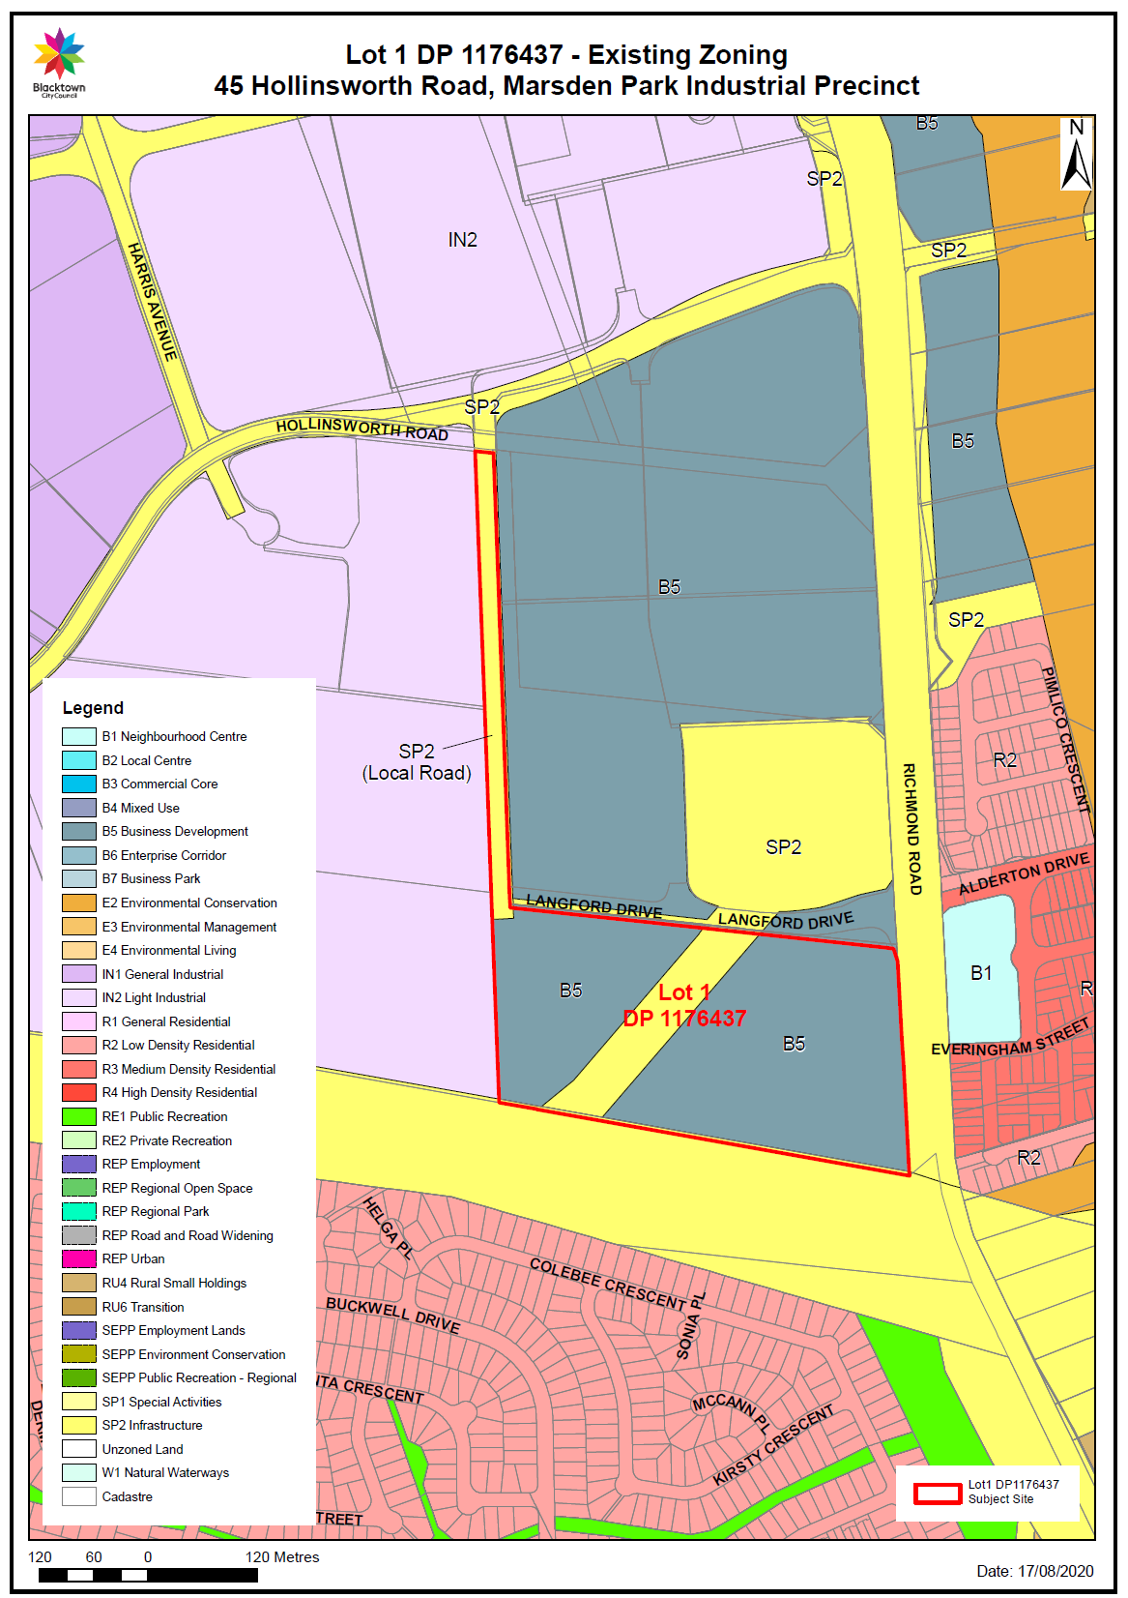

Figure 2- Existing Land zone

The larger part of the site is mainly zoned B5 Business Development with a small area zoned SP2 Infrastructure (Drainage). The site also contains an SP2 Infrastructure (Local Road) zoned access handle from Hollinsworth Road.

The objectives of the B5 Business Development zone are to:

* enable a mix of business and warehouse uses in locations that are close to, and that support the viability of, centres.
* allow development that is compatible with the scale, form and character of existing buildings and the surrounding area.

‘Hotel and motel accommodation’ and ‘office premises’ are prohibited land use in the B5 Business zone.

The ‘access handle’, zoned SP2 Infrastructure (Local Road) is not identified for acquisition on the Land Reservation Acquisition map and is not included in Council’s Contributions Plan 21 Marsden Park.

# Part 2 – Explanation of provisions

## Amendments to State Environmental Planning Policy

The proposed outcome will be achieved by amending the following:

1. Schedule 1 ‘Additional Permitted Uses’ to add ‘Hotel and motel accommodation’.
2. Maps: North West Growth Centre:

* Land Zoning Map - Sheet LZN_005
* Height of Building Map – Sheet HOB_005
* Floor Space Ratio – Sheet FSR_005

## Mapping amendments

It is proposed to rezone the SP2 Infrastructure (Local Road) to B5 Business development as shown in Figure 3.

The following Growth Centres SEPP Maps will be amended:

* Land Zoning Map - Sheet LZN_005
* Height of Building Map – Sheet HOB_005
* Floor Space Ratio – Sheet FSR_005

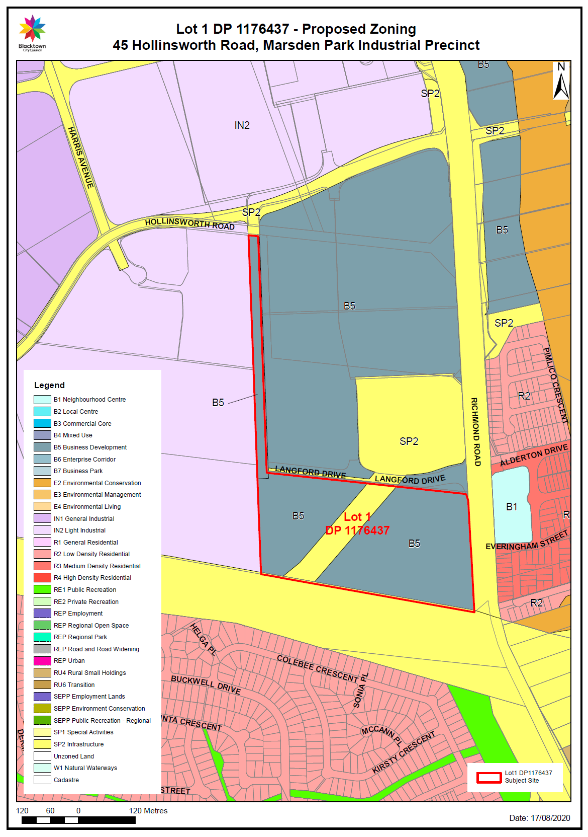

Figure 3 – Proposed land zone

# Part 3 – Justification

## Section A – Need for the Planning Proposal

1. **Is the Planning Proposal a result of any strategic study or report?**

The Planning Proposal is not the subject of a Council strategic study or report.

The Applicant has advised Council that AMAA have prepared a 20-year strategic overview and masterplan which has identified the need for for the Planning Proposal by seeking to add additional permissible uses for ‘hotel or motel accommodation’ and ‘office premises’ to Appendix 5, Schedule 1 of the Growth Centres SEPP.

Council does not support the inclusion of ‘office premises’ as an additional permitted use as that would set an undesirable precedent within the B5 Business Development zone and is not consistant as a standalone land use without the nature of the B5 zone.

Council supports the proposed rezoning of the SP2 Infrastructure (Local Road) zoned access handle to B5 Business Development. The access handle serves as a privately used driveway off Hollinsworth Road to the larger part of the site. The land was originally zoned to provide a future public road to service the site. However, following recent development, the site has frontage to Langford Drive, which connects to Richmond Road at a signalised intersection. This improved access negates the need for the SP2 Infrastructure (Local Road) zone.

1. **Is the Planning Proposal the best means of achieving the objectives or intended outcomes, or is there a better way?**

Yes. An amendment to the Growth Centres SEPP is required to add an additional permitted use of ‘Hotel and motel accommodation’ to Schedule 1 and rezone the SP2 Infrastructure (Local Road) to B5 Business Development.

## Section B – Relationship to strategic planning framework

1. **Is the Planning Proposal consistent with the objectives and actions contained within the applicable regional or district plan or strategy (including the Greater Sydney Region Plan)?**

The Planning Proposal is consistent with the Greater Sydney Region Plan and the Central City District Plan, to facilitate development consistent with the strategic significance of Blacktown City and the District.

A detailed assessment of consistency with the Greater Sydney Region Plan, Central City District Plan, Blacktown Community Strategic Plan and Blacktown Local Strategic Planning Statement is at Attachment 1.

1. **Is the Planning Proposal consistent with Council’s local strategy or other local strategic plan?**
2. **Blacktown Local Strategic Planning Statement**

The Planning Proposal is consistent with the Blacktown Local Strategic Planning Statement which is Council’s key strategic land use planning document to facilitate and manage future growth and development within the Blacktown City to 2036.

It is consistent with the vision, land use planning, the environment, liveability, productivity and infrastructure delivery in Blacktown City, to sustainably manage the significant growth forecasts for our City.

1. **Our Blacktown 2036 - Community Strategic Plan (CSP)**

The Community Strategic Plan outlines Council’s vision and aspirations for the future of the City. The vision is based on 6 Strategic Directions and Transformational Projects for the City.

The Planning Proposal is consistent with the Community Strategic Plan as detailed in Attachment 1.

1. **Is the Planning Proposal consistent with applicable State Environmental Planning Policies?**

This Planning Proposal will not contradict or hinder the application of any relevant SEPPs. Consistency with the relevant SEPPs and REPs is detailed in Attachment 2.

1. **Is the Planning Proposal consistent with applicable Ministerial Directions (s.9.1 Directions by the Minister)?**

The Planning Proposal is consistent with the relevant s. 9.1 Directions as detailed in Attachment 3.

## Section C – Environmental, Social and Economic Impacts

1. **Is there any likelihood that critical habitat or threatened species, populations or ecological communities, or their habitats, will be adversely affected as a result of the proposal?**

The Planning Proposal will not affect critical habitat or threatened species, populations or ecological communities, or their habitats.

1. **Are there any other likely environmental effects as a result of the Planning Proposal and how are they proposed to be managed?**

We do not expect any other likely environmental effects as a result of the Planning Proposal.

When a Development Application is lodged, a full assessment of environmental impacts will be undertaken with respect to the development site.

1. **How has the Planning Proposal adequately addressed any social and economic effects?**

We support the request to add ‘hotel or motel accommodation’ as an additional permissible use as it would support the unique use of the site as a place of public worship and as the national headquarters and administration centre for the Australian Ahmadiyya Muslim Association.

It is unlikely that the hotel or motel accommodation will be offered to anyone else other than to members of the Association to attend religious festivals, seminars, other educational offers and to visit the headquarters of the Association.

Additionally, ‘hotel or motel accommodation’ is a permissible land use in the B5 Business Development zone under Blacktown Local Environmental Plan 2015. The alignment of the Growth Centres SEPP with Blacktown LEP 2015 is an action in the North West Priority Growth Area – draft Land Use and Infrastructure Implementation Plan (LUIIP) prepared by the then Department of Planning and Environment in May 2017. Specifically, Action 5 of that Plan states that:

“*The Department will transfer planning controls from the State Environmental Planning Policy (Sydney Region Growth Centres) 2006 to local environmental plans through proposed amendments that will make development controls more consistent with the Standard Instrument Local Environmental Plan*.”

In relation to the proposed ‘office premises’, we recognise that ancillary office functions may be required to support the dominant use on the site as a place of public worship. Related office premises are generally considered ancillary to a place of public worship.

The scale and use of ancillary office premises would be assessed as part of a future Development Application. However, we do not believe there is sufficient justification to permit ‘office premises’ generally as an additional permitted use. To do so would allow the site to be developed for office uses completely independent from the site’s existing use.

General office premises should be located in planned centres. Further, ‘office premises’ are not permitted in the B5 Business Development zone under Blacktown LEP 2015, making it inconsistent with the intent of the LUIIP.

It is considered that permitting ‘office premises’ as an additional permitted use would detrimentally impact on the viability of nearby existing and planned centres, and set an undesirable precedent within the B5 Business Development zone. There are existing and planned centres within close proximity to the subject land that permit office premises, including:

* a centre directly opposite the site on Richmond Road zoned B1 Neighbourhood Centre,
* the Marsden Park Strategic Centre zoned B2 Local Centre within 2 km of the site, and
* large areas of land zoned B7 Business Park within 1 - 2 km of the site.

## Section D – State and Commonwealth interests

1. **Is there adequate public infrastructure for the Planning Proposal?**

There is adequate existing and planned public infrastructure in the Marsden Park Industrial Precinct to support the Planning Proposal. The Planning Proposal will not detrimentally impact on traffic volumes or movements in the Precinct. The site benefits from direct access to Langford Drive, which connects to Richmond Road at a signalised intersection.

1. **What are the views of State and Commonwealth public authorities consulted in accordance with the Gateway determination?**

Consultation with relevant State and Commonwealth authorities will be undertaken in conjunction with the exhibition of the Planning Proposal following the Gateway Determination, if required.

# Part 4 – Mapping

The proposed amendment to the Growth Centres SEPP requires amending the following maps:

* Land Zoning Map - Sheet LZN_005
* Height of Building Map – Sheet HOB_005
* Floor Space Ratio – Sheet FSR_005

# Part 5 – Community consultation

Community consultation will be carried out in accordance with the requirements of any Gateway Determination and the Environmental Plannning and Assessment Act.

# Part 6 – Timeline

The following project timeline provides an estimated timeframe for each stage of the Planning Proposal.

|  |  |
| --- | --- |
| **Stage** | **Estimated Date** |
| Resolution to prepare | September 2020 |
| Gateway Determination | December 2020 |
| Public exhibition | February 2021 |
| Consider submissions | March 2021 |
| Council resolution to adopt | April 2021 |
| Forward Planning Proposal to Department of Planning, Industry and Environment for the Minister to make the plan | May 2021 |

**Consistency with Greater Sydney Region Plan, Central City District Plan, Blacktown Community Strategic Plan and Blacktown Local Strategic Planning Statement**

**Attachment 1**

1. **Greater Sydney Region Plan – A Metropolis of 3 Cities**

|  |  |  |  |  |  |  |  |  |
| --- | --- | --- | --- | --- | --- | --- | --- | --- |
| **Direction** | **Objective** | **Does this objective apply to the Planning Proposal** | | | | **How does this Planning Proposal implement**  **the Direction and Objective?** | | |
| **Infrastructure and Collaboration** | | | | | | | | |
| A city supported by infrastructure | **Objective 1:**  Infrastructure supports the three cities | Yes | | | Consistent  The proposed amendments do not compromise the delivery of infrastructure that will support the growth of the Marsden Park area and the broader North West Growth Area. | | | |
| **Objective 2:**  Infrastructure aligns with forecast growth – growth infrastructure compact | Yes | | | Consistent. The proposed amendments support the growing AMAA community in the celebration of religious events their charity works. | | | |
| **Objective 3:**  Infrastructure adapts to meet future needs | Yes | | | Consistent. The proposed amendments are part of a 20 year masterplan for the continued and growing activities on the AMAA on this site. | | | |
| **Objective 4:**  Infrastructure use is optimised | Yes | | | Consistent. The proposed amendments will support the existing and continuing use of the site as a place of public worship. | | | |
| A collaborative city | **Objective 5:**  Benefits of growth realised by collaboration of governments, community and business | Yes | | | Consistent. The proposed amendments will support the use of the site as a place of worship and the functioning of the site as the head quarters of the AMAA. | | | |
|  |  |  | | |  | | | |
| **Liveability** |  |  | | |  | | | |
| A city for people | **Objective 6:**  Services and infrastructure meet communities’ changing needs | Yes | Consistent. The Planning Proposal will enable the community to use the site for uses associated with a place of public worship. | | | |
| **Objective 7:**  Communities are healthy, resilient and socially connected | Yes | Consistent. The site is a place of worship and education, connecting and supporting the community. Socially connected communities are healthy and resilient. | | | |
| **Objective 8:**  Greater Sydney’s communities are culturally rich with diverse neighbourhoods | Yes | Consistent. The AMAA is an active part of the growing cultural diversity of the North Western Growth Centre. | | | |
| **Objective 9:**  Greater Sydney celebrates the arts and supports creative industries and innovation | No | Not Applicable | | | |
| A city of great places | **Objective 10:**  Greater housing supply | No | Not Applicable | | | |
| **Objective 11:**  Housing is more diverse and affordable | No | Not Applicable | | | |
| **Objective 12:**  Great places that bring people together | Yes | Consistent. The place of worship and the educational offerings of the AMAA bring together people and communities and create and support community growth. | | | |
| **Objective 13:**  Environmental heritage is identified, conserved and enhanced | No | Not Applicable | | | |
| **Productivity** | | | | | | |
| A well-connected city | **Objective 14:**  A Metropolis of 3 Cities – integrated land use and transport creates walkable and 30- minute cities | Yes | Consistent. The amendment will permit the additional use of ‘hotel or motel accommodaiton’. Any uses not permitted on site, can be accessed in walking distance in the closeby B1 and B2 centres. | | | |
| **Objective 15:**  The Eastern, GPOP and Western Economic Corridors are better connected and more competitive. | No | Not Applicable | | | |
| **Objective 16:**  Freight and logistics network is competitive and efficient | No | Not Applicable | | | |
| **Objective 17:**  Regional connectivity is enhanced | No | Not Applicable | | | |
| Jobs and skills for the city | **Objective 18:**  Harbour CBD is stronger and more competitive | No | Not Applicable | | | |
| **Objective 19:**  Greater Parramatta is stronger and better connected | No | Not Applicable | | | |
| **Objective 20:**  Western Sydney Airport and Badgerys Creek Aerotropolis are economic catalysts for Western Parkland City | No | Not Applicable | | | |
| **Objective 21:**  Internationally competitive health, education, research and innovation precincts | No | Not Applicable | | | |
| **Objective 22:**  Investment and business activity in centres | No | Not Applicable | | | |
| **Objective 23:**  Industrial and urban services land is planned, retained and managed | No | Not Applicable | | | |
| **Objective 24:**  Economic sectors are targeted for success | NO | Not Applicable | | | |
| **Sustainability** | | | | | | | |
| A city in its landscape | **Objective 25:**  The coast and waterways are protected and healthier | No | | Not Applicable | | | |
| **Objective 26:**  A cool and green parkland city in the South Creek corridor | No | | Not Applicable | | | |
| **Objective 27:**  Biodiversity is protected, urban bushland and remnant vegetation is enhanced | No | | Not Applicable | | | |
| **Objective 28:**  Scenic and cultural landscapes are protected | No | | Not Applicable | | | |
| **Objective 29:**  Environmental, social and economic values in rural areas are protected and enhanced | No | | Not Applicable | | | |
| **Objective 30:**  Urban tree canopy cover is increased | Yes | | Consistent.Existing trees are retained. | | | |
| **Objective 31:**  Public open space is accessible, protected and enhanced | No | | Not Applicable | | | |
|  | **Objective 32:**  The Green Grid links parks, open spaces, bushland and walking and cycling paths | No | | Not Applicable | | | |
| An efficient city | **Objective 33:**  A low-carbon city contributes to net-zero emissions by 2050 and mitigates climate change | Yes | | Consistent. Existing trees are retained contributing to tree canopy cover. Any building works, will have to comply with relevant development controls. | | | |
| **Objective 34:**  Energy and water flows are captured, used and re-used | Yes | | Consistent. Blacktown development controls apply. | | | |
| **Objective 35:**  More waste is re-used and recycled to support the development of a circular economy | Yes | | Consistent. Blacktown development controls apply. | | | |
| A resilient city | **Objective 36:**  People and places adapt to climate change and future shocks and stresses | Yes | | Consistent. Blacktown development controls apply. | | | |
| **Objective 37:**  Exposure to natural and urban hazards is reduced | Yes | | Consistent. The site is not flood prone and is not in a bush fire zone. Existing trees are retained and the natural drainage corridor retained. | | | |
| **Objective 38:**  Heatwaves and extreme heat are managed | Yes | | Consistent. The existing trees are retained and Blacktown planning controls apply. | | | |

|  |  |  |  |
| --- | --- | --- | --- |
| **Implementation** | | | |
| Implementation | **Objective 39:**  A collaborative approach to city planning | No | Not Applicable |
| **Objective 40:**  Plans refined by monitoring and reporting | No | Not Applicable |

1. **Central City District Plan**

|  |  |  |  |
| --- | --- | --- | --- |
| **Planning Priorities** | **Does this priority apply to the Planning Proposal** | | **How does this Planning Proposal implement the Planning Priority and Action** |
| **Infrastructure and Collaboration** | | | |
| **C 1:**  Planning for a city supported by Infrastructure | Yes | | Consistent. The 20 year masterplan for the continued and increased use of the site, supports the growing community in the North West Growth area and serves to connect the community. |
| **C 2:**  Working through collaboration | Yes | | Consistent. The Planning Proposal supports the continued and extended use of the site as a place of worship and community life, supporting the community working in the emerging local economy. |
| **Liveability** | | | |
| **C 3:**  Providing services and social infrastructure to meet people’s changing needs | Yes | Consistent. As a place of worship and as the national head quarters of the AMAA and their charities, the AMAA provides services to the growing community. | |
| **C 4:**  Fostering healthy, creative, culturally rich and socially connected communities | Yes | Consistent. As a place of worship the site offers a space to connect the culturally rich and diverse community of the North West Growth Area. | |
| **C 5:**  Providing housing supply, choice and affordability, with access to jobs, services and public transport | No | Not Applicable | |
| **C 6:**  Creating and renewing great places and local centres, and respecting heritage the District’s heritage | Yes | Consistent. The use of the site is respecting the District’s heritage and it will support the current and future local centres. | |

|  |  |  |  |  |
| --- | --- | --- | --- | --- |
| **Productivity** | | | | |
| **C 7:**  Growing a stronger and more competitive Greater Parramatta | No | | Not Applicable | |
| **C 8:**  Delivering a more connected and competitive GPOP Economic Corridor | No | | Not Applicable | |
| **C 9:**  Delivering integrated land use and transport planning a 30-minute city | No | | Not Applicable | |
| **C 10:**  Growing investment, business opportunities and jobs in strategic centres | No | | Not Applicable | |
| **C 11:**  Maximising opportunities to attract advanced manufacturing and innovation in industrial and urban services land | No | | Not Applicable | |
| **C 12:**  Supporting growth of targeted industry sectors | No | | Not Applicable | |
| **Sustainability** | | | | |
| **C 13:**  Protecting and improving the health and enjoyment of the District’s waterways | | Yes | | Consistent, The existing SP drainage land is retained and changes will have to comply with Council’s development controls. |
| **C 14:**  Creating a Parkland City urban structure and identity, with South Creek as a defining spatial element | | No | | Not Applicable |
| **C 15:** Protecting and enhancing bushland, biodiversity and scenic and cultural landscapes | | Yes | | Consistent. Existing trees and the natural drainageland are retained. |
| **C 16:** Increasing urban tree canopy cover and delivering Green Grid connections | | Yes | | Partly Consistent. Existing trees are retained, an increase in canopy cover can be achieved through DA conditions. Ther Green Grid connects public open space. This is a privately owned site. |
| **C 17:** Delivering high quality open space | | No | | Not Applicable |

|  |  |  |  |
| --- | --- | --- | --- |
| **Sustainability** | | | |
| **C 18:**  Better managing rural Areas | No | Not Applicable |
| **C 19:**  Reducing carbon emissions and managing energy, water and waste efficiently | Yes | Consistent. The building works to implement the 20 year masterplan will have to comply with the relevant Council development controls and BASIX. |
| **C 20:**  Adapting to the impacts of urban and natural hazards and climate change | Yes | Consistent. The building works to implement the 20 year masterplan will have to comply with the relevant Council development controls and BASIX. |
| **Implementation** | | |
| **C 21:**  Preparing local strategic planning statements informed by local strategic planning | No | Not Applicable |
| **C 22:** Monitoring and reporting on the delivery of the plan | No | Not Applicable |

1. **Blacktown Community Strategic Plan**

|  |  |
| --- | --- |
| **Strategic Direction** | **Compliance** |
| A vibrant and inclusive City | Consistent. The use as a place of worship and the educational offerings, contributes greatly to a vibrant and inclusive city. |
| A clean, sustainable and healthy environment | Consistent. Existing trees and natural drainage corridors are retained. The activites on site do not have a negative impact on the environment. |
| A smart and prosperous economy | Consistent. The AMAA”s charities and educational offers contribute to a smart and prosperous economy. |
| A growing city supported by accessible infrastructure | Consistent. The use of the site as a place of worship will not hinder transport infrastructure. |
| A sporting and active city | Consistent. Sport activites are part of the youth work of the AMAA on this site, with cricket pitches, an informal soccer field and planned basket ball courts on site. |
| A leading city | Consistent The AMAA is an active part of the multi cultural community of Blacktown and is internationally active. |
|  |  |

1. **Blacktown Local Strategic Planning Statement**

Blacktown Local Strategic Planning Statement outlines a vision for the next 20 years and beyond for land use planning, the environment, liveability, productivity and infrastructure delivery in Blacktown City, to sustainably manage the significant growth forecasts for our City.

The Planning Proposal is consistent with the Blacktown Local Strategic Planning Statement.

**Consistency with Applicable SEPPs and REPs**

**Attachment 2**

| State Environmental Planning Policy | Consistency |
| --- | --- |
| SEPP No 19 - Bushland in Urban Areas | Yes  The existing patches of Shales Plain Woodland will be retained. |
| SEPP No 21 Caravan Parks | Yes  This Planning Proposal will not contradict or hinder the application of this SEPP. The site is not intended to be used as a caravan park. |
| SEPP No 33 - Hazardous and Offensive Development | Yes  This Planning Proposal will not contradict or hinder the application of this SEPP. No hazardous or offensive development is enabled by they Planning Proposal. |
| SEPP No 36 - Manufactured Home Estates | Yes  This Planning Proposal will not contradict or hinder the application of this SEPP. It is not intended to use the site as a manufactured Home Estate. |
| SEPP No 50 - Canal Estate Development | Yes  This Planning Proposal will not contradict or hinder the application of this SEPP. It is not intended to use this site for a canal estate development. |
| SEPP No 55 - Remediation of Land | Yes  This Planning Proposal will not contradict or hinder the application of this SEPP. There is no known contamination in the land. |
| SEPP No 64 - Advertising and Signage | Yes  This Planning Proposal will not contradict or hinder the application of this SEPP. There are no plans for the use of advertising or large signage. |
| SEPP No 65 - Design Quality of Residential Apartment Development | Yes  This Planning Proposal will not contradict or hinder the application of this SEPP. Residential apartments are not permissible on the site. |
| SEPP No 70 - Affordable Housing (Revised Schemes) | Yes  This Planning Proposal will not contradict or hinder the application of this SEPP. Residential accommodation is not a permissible use in the B5 Zone. |
| SEPP (Affordable Rental Housing) 2009 | Yes  This Planning Proposal will not contradict or hinder the application of this SEPP. Residential accommodation is not a permissible use in the B5 Zone. |
| SEPP (Building Sustainability Index: BASIX) 2004 | Yes. This Planning Proposal aims to add “hotel or motel accommodation’as a permissible use under the B5 zoning. |
| SEPP (Concurrences) 2018 | Yes  This Planning Proposal will not contradict or hinder the application of this SEPP. |
| SEPP (Educational Establishments and Child Care Facilities) 2017 | Yes  This Planning Proposal will not contradict or hinder the application of this SEPP. The educational offers are part of the use of the site as place of worship. The design and construction of the buildings used, will compy with the relevant development controls. |
| SEPP (Exempt and Complying Development Codes) 2008 | Yes  This Planning Proposal will not contradict or hinder the application of this SEPP. |
| SEPP (Housing for Seniors or People with a Disability) 2004 | Yes  This Planning Proposal will not contradict or hinder the application of this SEPP. The Planning Proposal does not change the use of the site as a place of worship. |
| SEPP (Infrastructure) 2007 | Yes  This Planning Proposal will not contradict or hinder the application of this SEPP. |
| SEPP (Mining, Petroleum Production and Extractive Industries) 2007 | Yes  This Planning Proposal will not contradict or hinder the application of this SEPP. |
| SEPP (Miscellaneous Consent Provisions) 2007 | Yes  This Planning Proposal will not contradict or hinder the application of this SEPP. |
| SEPP (Primary Production and Rural Development) 2019 | Yes  This Planning Proposal will not contradict or hinder the application of this SEPP. The site is not in a rural area and no primary production takes place on site. |
| SEPP (State and Regional Development) 2011 | Yes  This Planning Proposal will not contradict or hinder the application of this SEPP. |
| SEPP (State Significant Precincts) 2005 | Yes  This Planning Proposal will not contradict or hinder the application of this SEPP. |
| SEPP (Sydney Drinking Water Catchment) 2011 | Yes  This Planning Proposal will not contradict or hinder the application of this SEPP. |
| SEPP (Sydney Region Growth Centres) 2006 | Not Applicable  This Planning Proposal aims to amend this SEPP to include the additional permissible use of ‘hotel or motel accommodation. Further than that, the use of the site complies with this SEPP. |
| SEPP (Urban Renewal) 2010 | Not Applicable  This Planning Proposal will not contradict or hinder the application of this SEPP. The site is not in a urban renewal area. |
| SEPP (Vegetation in Non-Rural Areas) 2017 | Yes  This Planning Proposal will not contradict or hinder the application of this SEPP. The existing vegetation on site will be retained. |
| SEPP (Western Sydney Employment Area) 2009 | No Applicable  This Planning Proposal will not contradict or hinder the application of this SEPP. The site is not located in the Western Sydney Employment area. |
| SEPP (Western Sydney Parklands) 2009 | Not Applicable  This Planning Proposal will not contradict or hinder the application of this SEPP. The site is not located in the Western Sydney Parklands. |
| **Sydney Regional Environmental Plans** | **Consistency** |
| Sydney REP No 9 - Extractive Industry (No 2 - 1995) | Not Applicable  This Planning Proposal will not contradict or hinder the application of this REP. No extractive industries are using this site. |
| Sydney REP No 20 - Hawkesbury-Nepean River (No 2 - 1997) | Not Applicable  This Planning Proposal will not contradict or hinder the application of this REP. |
| Sydney REP No 30 - St Marys | Not applicable  This Planning Proposal will not contradict or hinder the application of this REP. The site is not in the St Marys area. |
| Sydney REP (Sydney Harbour Catchment) 2005 | Not applicable  This Planning Proposal will not contradict or hinder the application of this REP |

**Consistency with relevant Section 9.1 Directions by the Minister**

**Attachment 3**

| Direction | Consistency of Planning Proposal |
| --- | --- |
| 1. **Employment and Resources** | |
| 1. Business and Industrial Zones | The Planning Proposal applies to land in the Marsden Park Industrial Precinct and is consistent with this Direction. The use of the site as a place of worship is permitted in the B5 zone. |
| 1. Rural Zones | Not Applicable |
| 1. Mining, Petroleum Production and Extractive Industries | Not Applicable |
| 1. Oyster Aquaculture | Not Applicable |
| 1. Rural Lands | Not Applicable |
| 1. **Environment and Heritage** | |
| 1. Environment Protection Zones | Not Applicable |
| 1. Coastal Management | Not Applicable |
| 1. Heritage Conservation | Not Applicable |
| 1. Recreation Vehicle Areas | Not Applicable |
| 1. Application of E2 and E3 Zones and Environmental Overlays in Far North Coast LEPs | Not Applicable |
| 1. **Housing, Infrastructure and Urban development** | |
| 1. Residential Zones | Not Applicable |
| 1. Caravan Parks and Manufactured Home Estates | Not Applicable |
| 1. Home Occupations | Not Applicable |
| 1. Integrating Land Use and Transport | The Marsden Park Industrial Precinct is well serviced by public transport including bus and future rail services. |
| 1. Development Near Regulated Airports and Defence Airfields | Not Applicable |
| 1. Shooting Ranges | Not Applicable |
| 1. Reduction in non-hosted short term rental accommodation period | Not Applicable |
| 1. **Hazard and Risk** |  |
| 1. Acid Sulphate Soils | Not Applicable |
| 1. Mine Subsidence and Unstable Land | Not Applicable |
| 1. Flood Prone Land | Not Applicable |
| 1. Planning for Bushfire Protection | Not Applicable |
| 1. **Regional Planning** | |
| * 1. [Revoked] | - |
| * 1. Sydney Drinking Water Catchments | Not Applicable |
| * 1. Farmland of State and Regional Significance on the NSW Far North Coast | Not Applicable |
| * 1. Commercial and Retail Development along the Pacific Highway, North Coast | Not Applicable |
| * 1. [Revoked] | - |
| * 1. [Revoked] | - |
| * 1. [Revoked] | - |
| * 1. [Revoked] | - |
| * 1. North West Rail Link Corridor Strategy | Not Applicable |
| * 1. Implementation of Regional Plans | The Planning Proposal is consistent with this Direction. |
| * 1. Development of Aboriginal Land Council land | Not applicable |
| 1. **Local Plan Making** | |
| * 1. Approval and Referral Requirements | The Planning Proposal is consistent with this Direction. |
| * 1. Reserving Land for Public Purposes | The Planning Proposal is consistent with this Direction. |
| * 1. Site Specific Provisions | The Planning Proposal is consistent with this Direction. |
| 1. **Metropolitan Planning** | |
| * 1. Implementation of A Plan for Growing Sydney | The Planning Proposal is consistent with this Direction. The implementation of the 20 year masterplan for the site, enabled by this Planning Proposal will as a place of worship serve the growing community of the Growth Centre. |
| * 1. Implementation of Greater Macarthur Land Release Investigation | Not Applicable |
| * 1. Parramatta Road Corridor Urban Transformation Strategy | Not Applicable |
| * 1. Implementation of North West Priority Growth Area Land Use and Infrastructure Implementation Plan | The Planning Proposal is consistent with this Direction. |
| * 1. Implementation of Greater Parramatta Priority Growth Area Interim Land Use and Infrastructure Implementation Plan | Not Applicable |
| * 1. Implementation of Wilton Priority Growth Area Interim Land Use and Infrastructure Implementation Plan | Not Applicable |
| * 1. Implementation of Glenfield to Macarthur Urban Renewal Corridor | Not applicable |
| * 1. Implementation of Western Sydney Aerotropolis Interim Land Use and Infrastructure Implementation Plan | The Planning Proposal is consistent with this Direction. |
| * 1. Implementation of Bayside West Precincts 2036 Plan | Not Applicable |
| * 1. Implementation of Planning Proposals for the Cooks Cove Precinct | Not Applicable |